8/30/2022

Mortgage Calculator



Carl M

Appwrk.com

Contents

**Introduction** 2

**Objectives** 4

**Mission** 5

**Problem Faced** 6

**Solution Proposed** 6

**Roles and Prospect Users** 7

1. Admin Interface 7

a. Admin Login Cred 7

2. End User 11

a. Customer Login Cred. 12

**List of Steps and Technology stack used** 16

Step 1: Install PHP 16

Step 2: Download Opencart4.0.0 18

Step 3: Installation of the OpenCart into Xampp 20

**Things to remember after OpenCart theme installation** 24

# **Introduction**

Mortgage Calculator is the best Online Calculator to check the EMI of the loan amount. All banks provide different types of loan like home loan, car loan, study loan etc. they have set the amount to be paid on the behalf of Interest rate and time duration. According to the time duration and rate of interest they have set the amount on the behalf of Mortgage formula.

They need to find the EMI in the monthly instalment to pay. Whenever any of the person apply for the loan from the bank or other financial organization, they need to calculate the EMI and total amount to be paid so thus they can find the total interest how much they need to pay. Sometime the person like to pay some part of the payment as a down payment so in this case the interest will be applicable on the rest of the amount and calculate the interest or EMI on the behalf of pending amount.

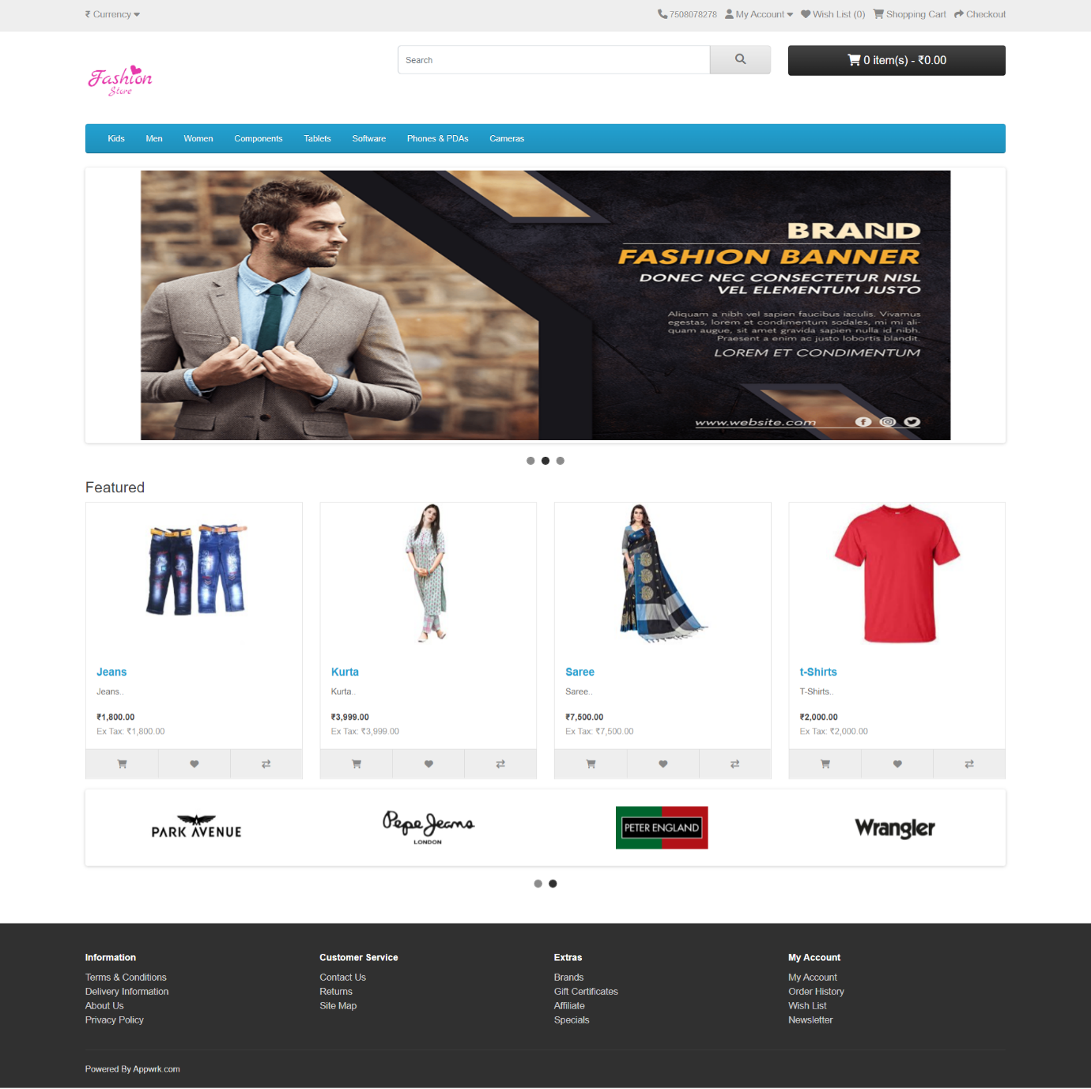

# **Objectives**

* We can easily calculate the EMI of the Loan amount.
* No need to add the down payment for the Calculation
* End-user need to add his Basic Details like Name, Email, Mobile No.
* End-user can view the record into the Yearly and Monthly graph to view the details of instalment.
* After following all option End-user can easily take the printout of instalment report.

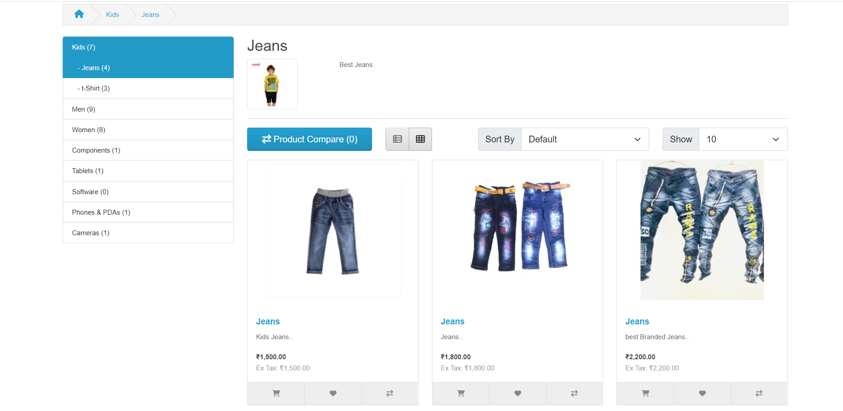

# **Mission**

Our Main target is to develop a product which would be helpful for the Financial Organization or Normal User who can easily calculate the EMI and Total Amount how much they need to pay after getting the loan from the Bank or Financial Organization. All these things are very important. They can easily access this **website** without any calculation. They just need to enter the few basic details after that they can easily use this website to get the details of payment.

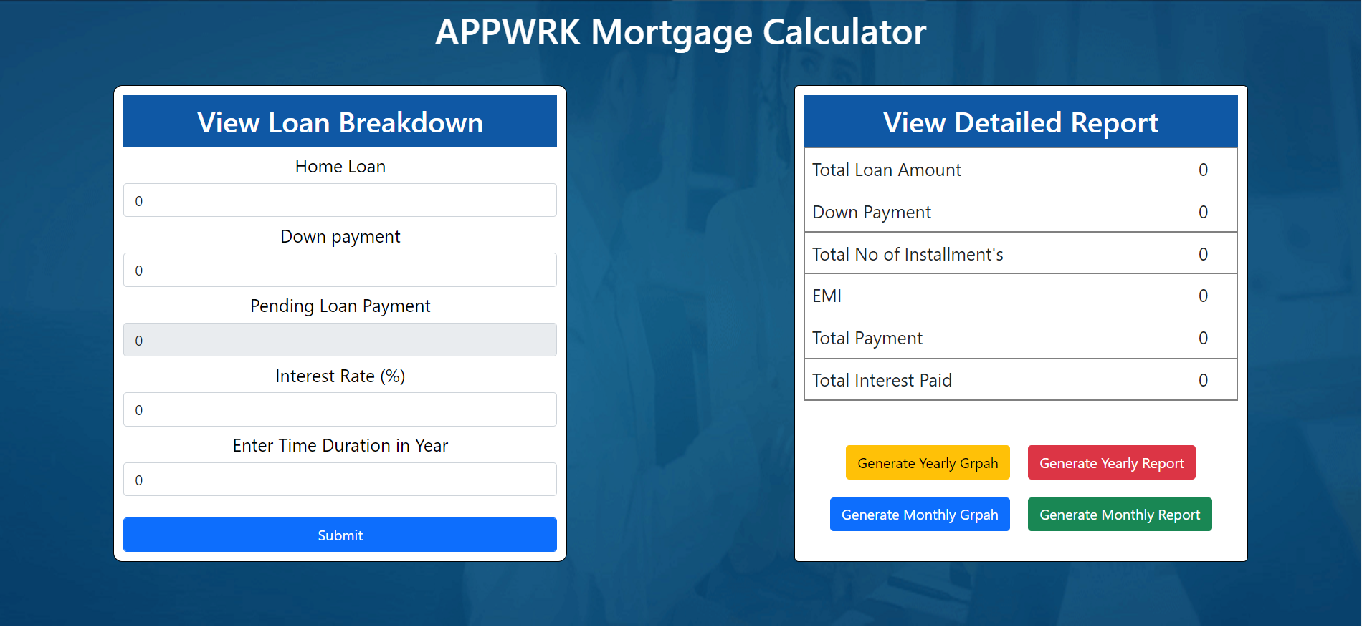

# **Problem Faced**

1. During the calculation, I have to face the issues related to the calculation and other relevant libraries which are very important for the calculation.
2. I have faced the issues related to the **Printing** and **Graph** library in React
3. For the Backend connection, I have used the **Node JS** and **Express JS** and **API integration Task**

# **Solution Proposed**

1. For the calculation, I need to get the help of the states and props which can be used to store the location details of the **Loan Amount, Interest Rate, Down Payment** and **Time duration.**
2. I have installed **React-To-Print** and **recharts** for graph and printing option.
3. I have used the **Navigate** from **react-router-dom** library option to link and route to another page.

# **Roles and Prospect Users**

## End User

* The End-Users just need to add his basic details like Name, Email-Id, Mobile No to Register.



* When the user register himself then he can easily jump to the next webpage for entering his basic details like:

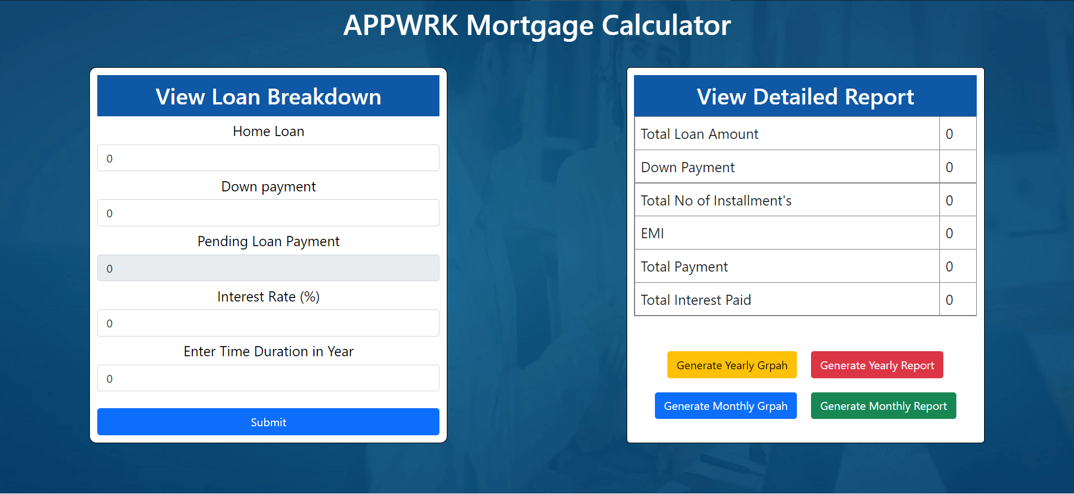

* After filling the basic details like initial **Loan Amount**, **Down Payment,** **Interest Rate, Time duration in Year** then need to click on the submit button to view all details.

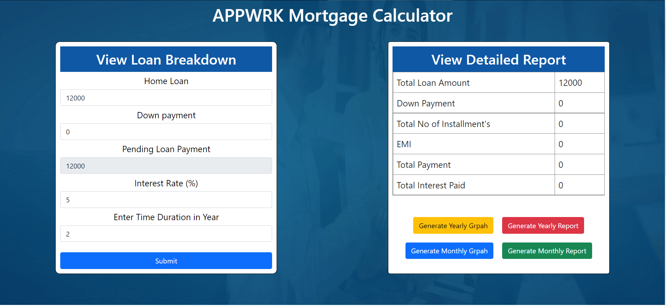

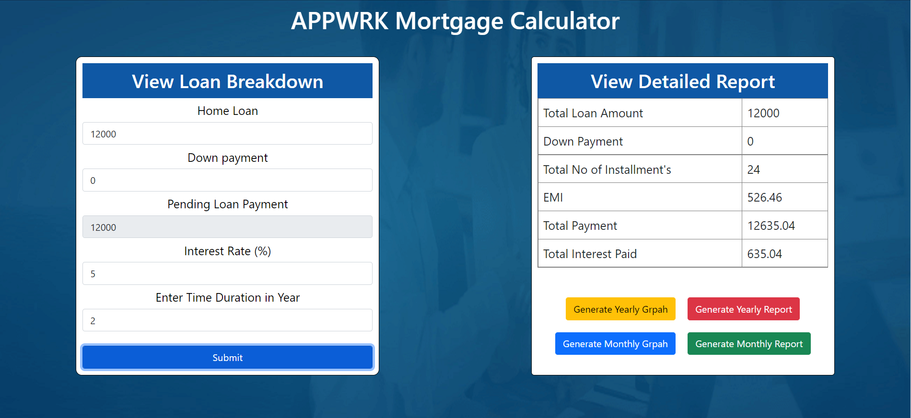

* After that when we want to view the record into the **Yearly** and **Monthly Report** of the instalment then just need to click on the relevant button.

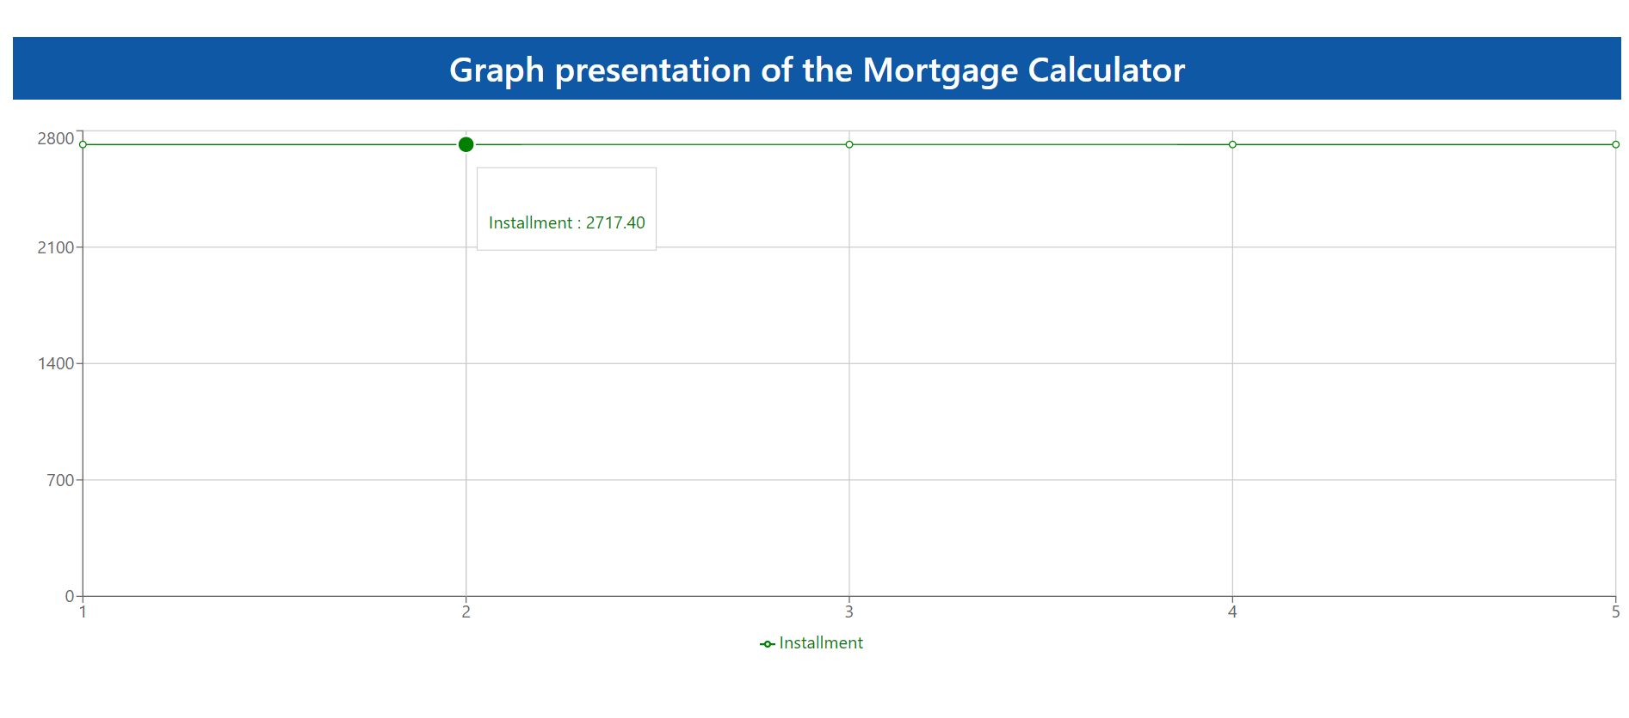

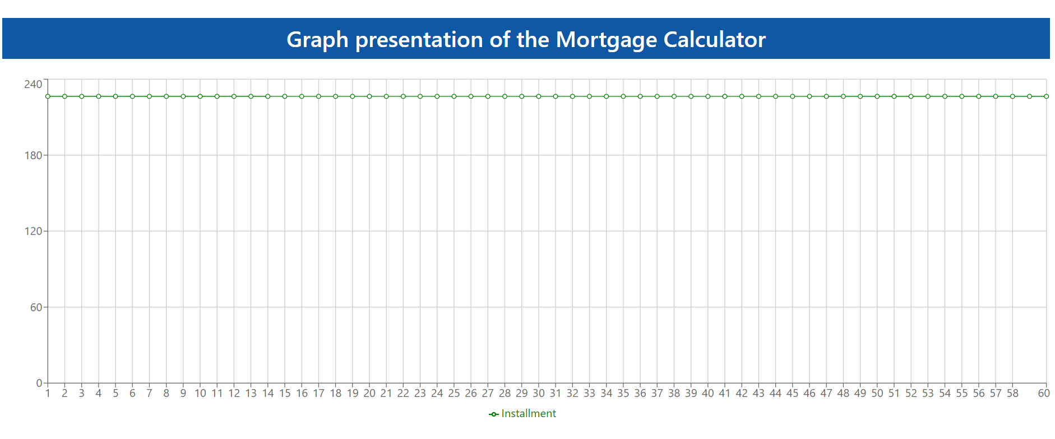

* After that when we need to click on the report so thus, we can use the option of the printing.

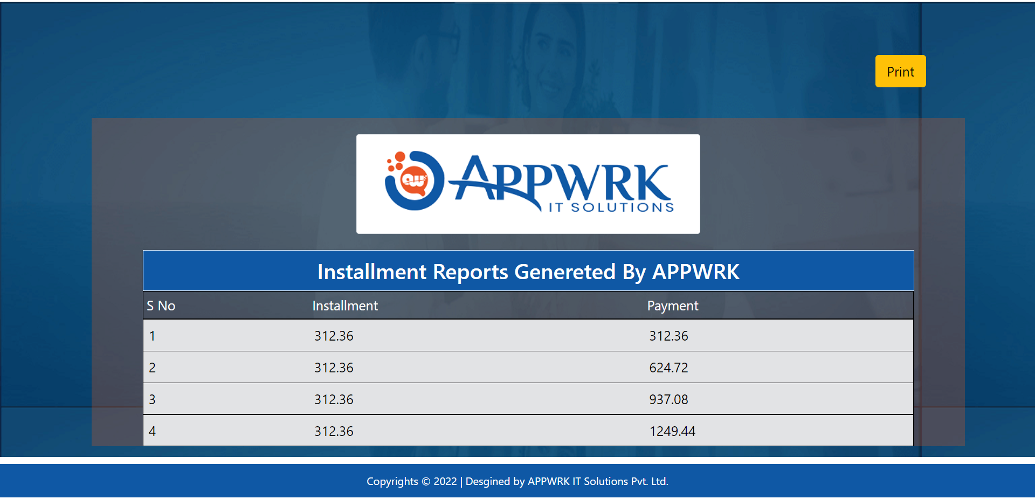

* From the print button we can easily get the print of the generated report for the future use.

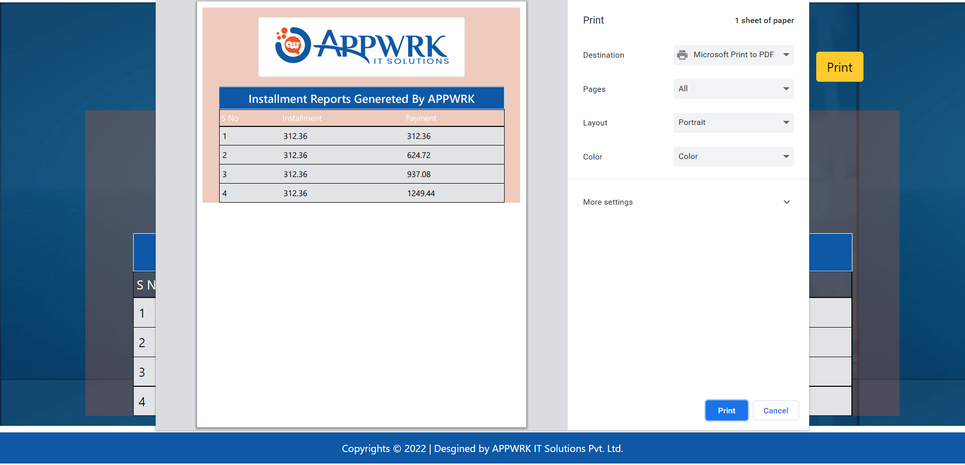

**URL: Pending to deploy**

# **List of Steps and Technology stack used**

## Step 1: Install of Front

* Node JS
* Express JS
* React JS

**Link to Download:** [**https://nodejs.org/en/**](https://nodejs.org/en/)

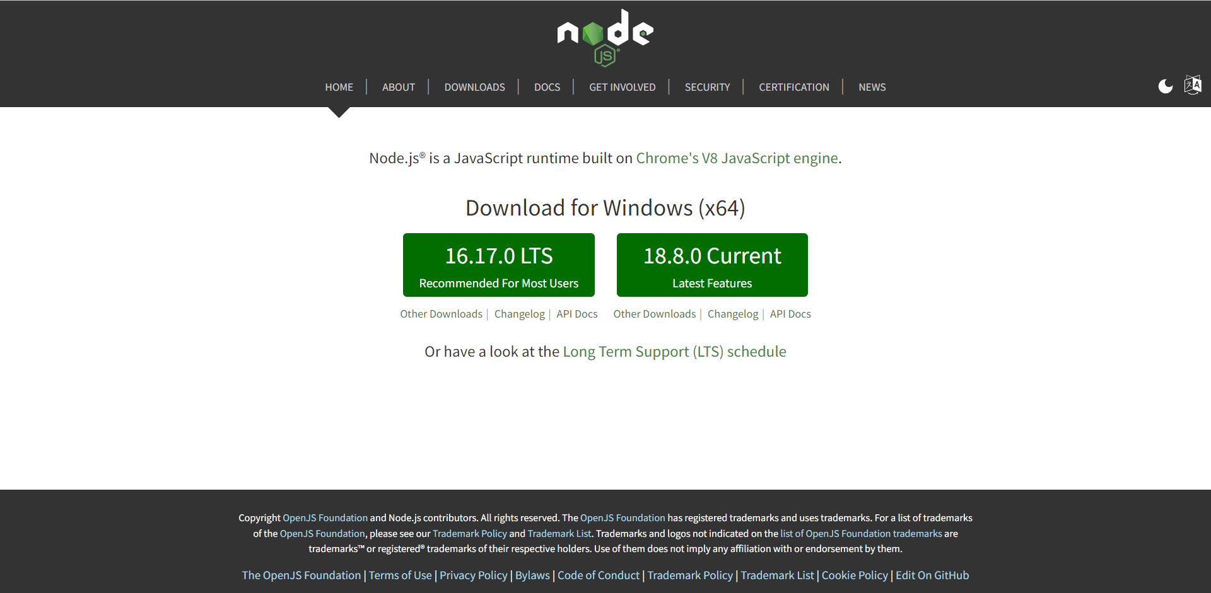

After downloading the Software just need to double Click on the Exe file to install into the System. After that a New Windows will be appear in which we just need to select the list of components to be installed with the **Node JS** version like:

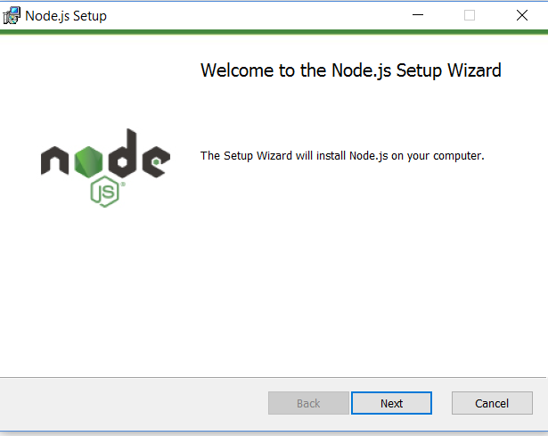

After that we just need to select the location of the **NodeJS folder** where we have installed **Node JS** like in Drive of the System whatever it is **C drive or any other drive**. Then we just need to click on Next, Next and finish. I have installed PHP in **C Drive** under the **Program files** with the name of the Folder.

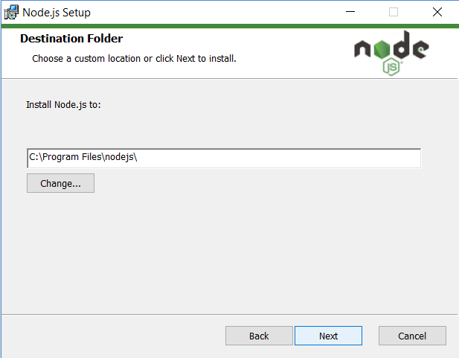

After this window, we need to set the **Environment path, Node JS, NPM Package Manager** and **Add to Path** then need to click on Next.

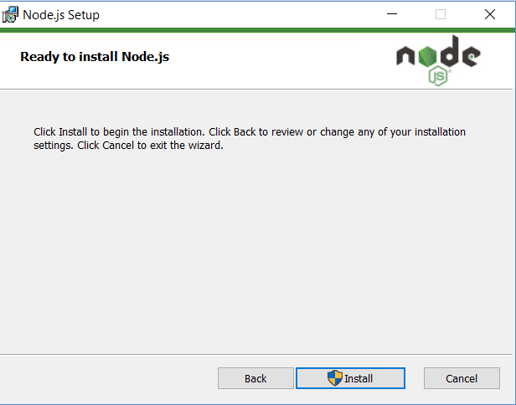

Here from the next window, we just need to click on the install button to install the Software into the System.

## Step 2: Create React App

After the installation of Node JS from the **VSCode** we just need to enter the command into the terminal to create the **React App** to create the new project into the React.

**Npx create-react-app mortagecalculator**

After that just need to hit enter for installing the require files and library for the **React JS** project. It will take some time to install all packages.

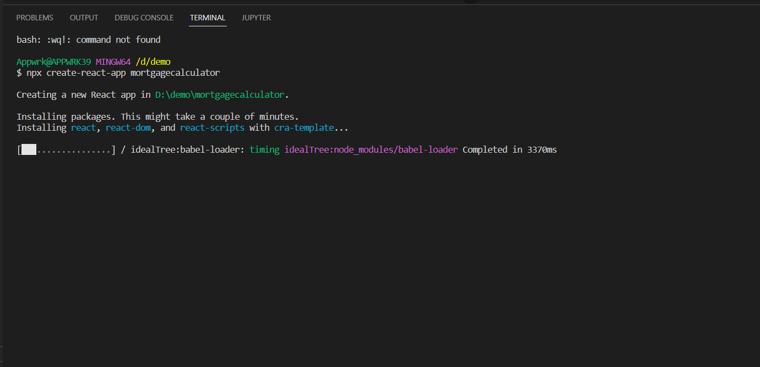

After this we need to install **react router dom, react to pdf and recharts** library into the App with the help of the below command.

**npm install react-router-dom react-to-pdf recharts**

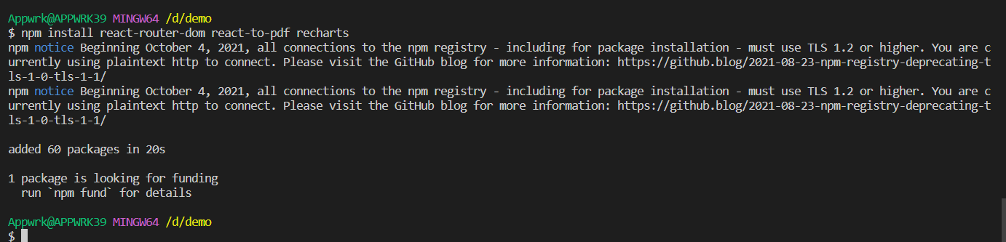

After that, we need to get the help of another command to start the front-end server. First time when we use this command, it will take some time to implement all libraries and implementation of those.

**npm start**

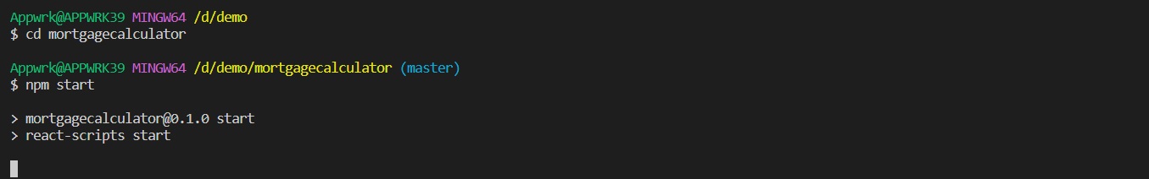

## Step 3: Installation of the Express JS

For the backend of the Express JS we need to follow some of the commands in the terminal or bash we can use any of these.

This is the first command is used to generate the **Package.json** file in which we need to store all the details of the library used in the backend.

**npm init -y**



After the above command we need to install the **express, mongoose, nodemon and cors** into the backend project for the connection and other API integration task.





After that we just need to add the “type”:”module” into the package.JSON file then the whole file will look like:

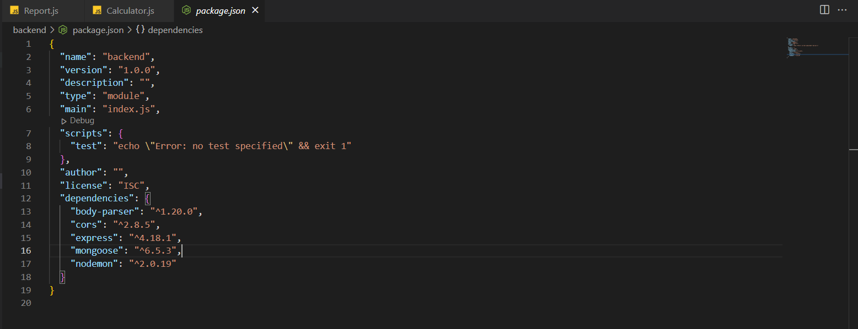

After that according to the MVC structure we need to create routes, controller and models folder into the backend for the further process.

First of all need to go to the **Models** folder and create a **Users.js** file and add the schema related to the column and data types into the mongoDB.

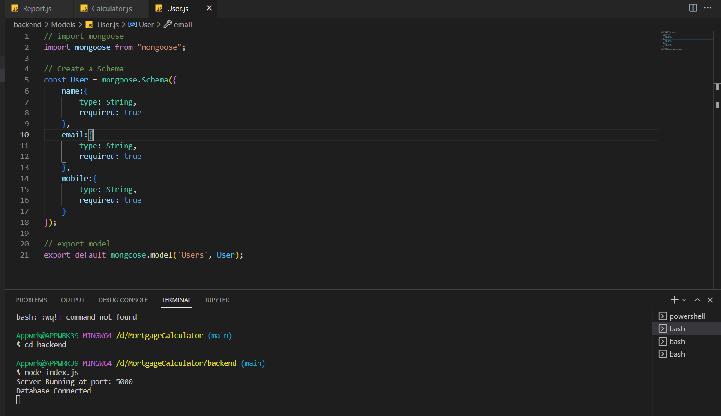

Then under the controller folder need to create the userController.js to manage the methods for **create** and **get**

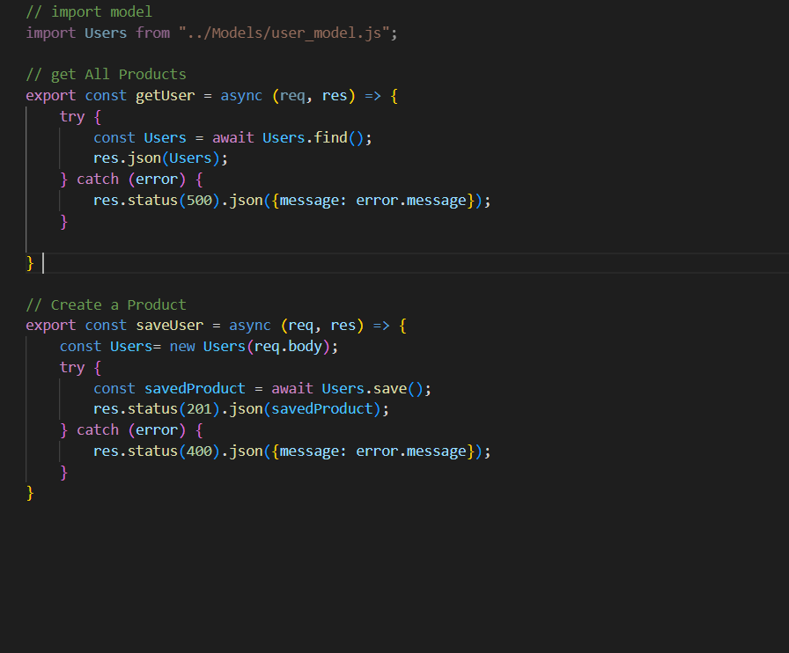

Inside the routes folder here we need to create a file with the name of **index.js** to set the name of routes and pass the links of the API

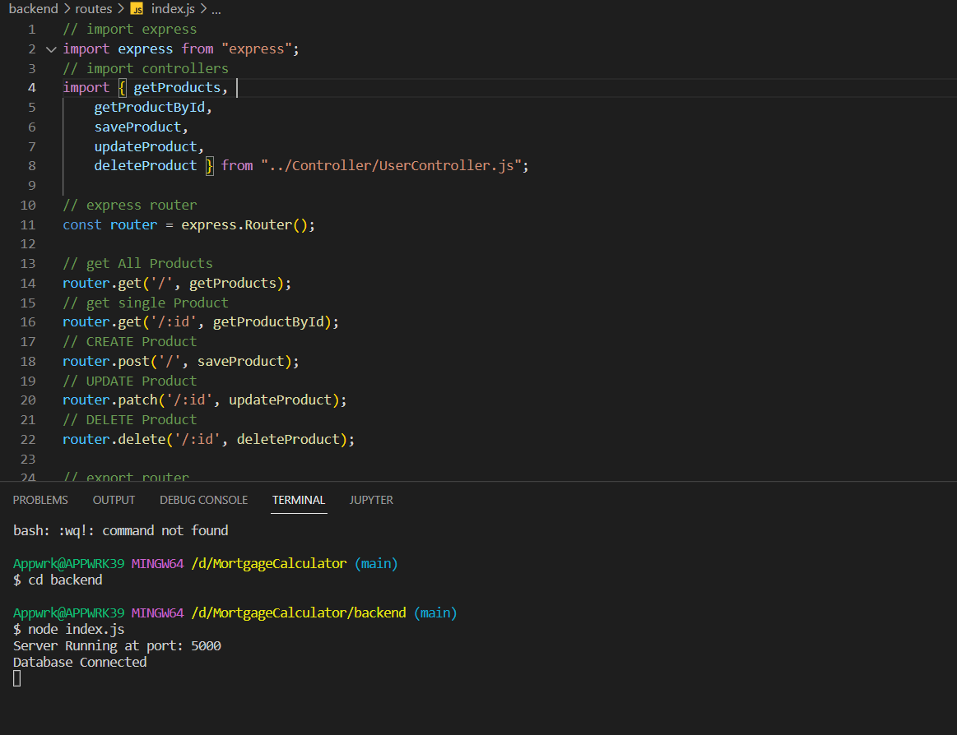

After that in the root directory of the backend create a file with the name of **index.js** and config the connection and use the routes and set the set url.

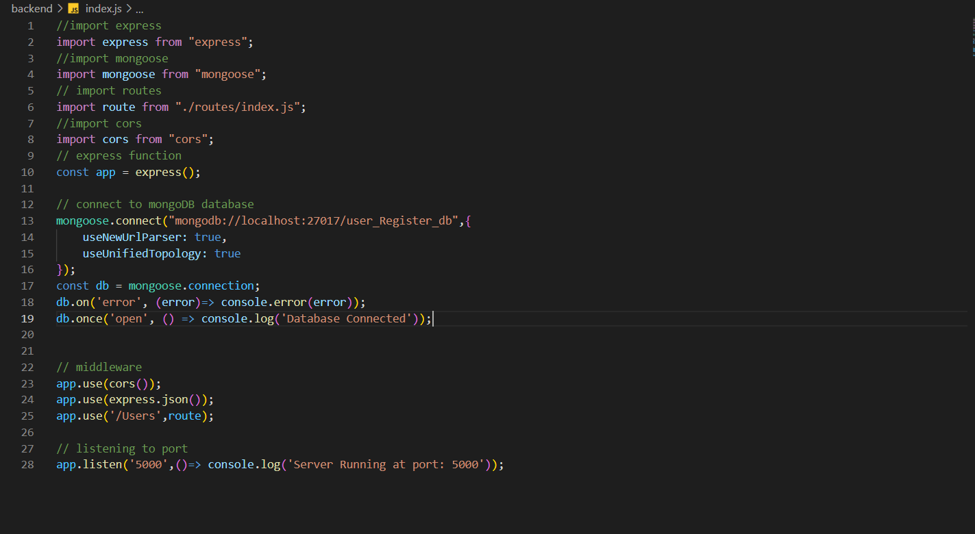

Now need to click on the Continue for the further setting and configuration. Here we need to check the list of Extensions are enable or not into the **PHP Control Panel**.

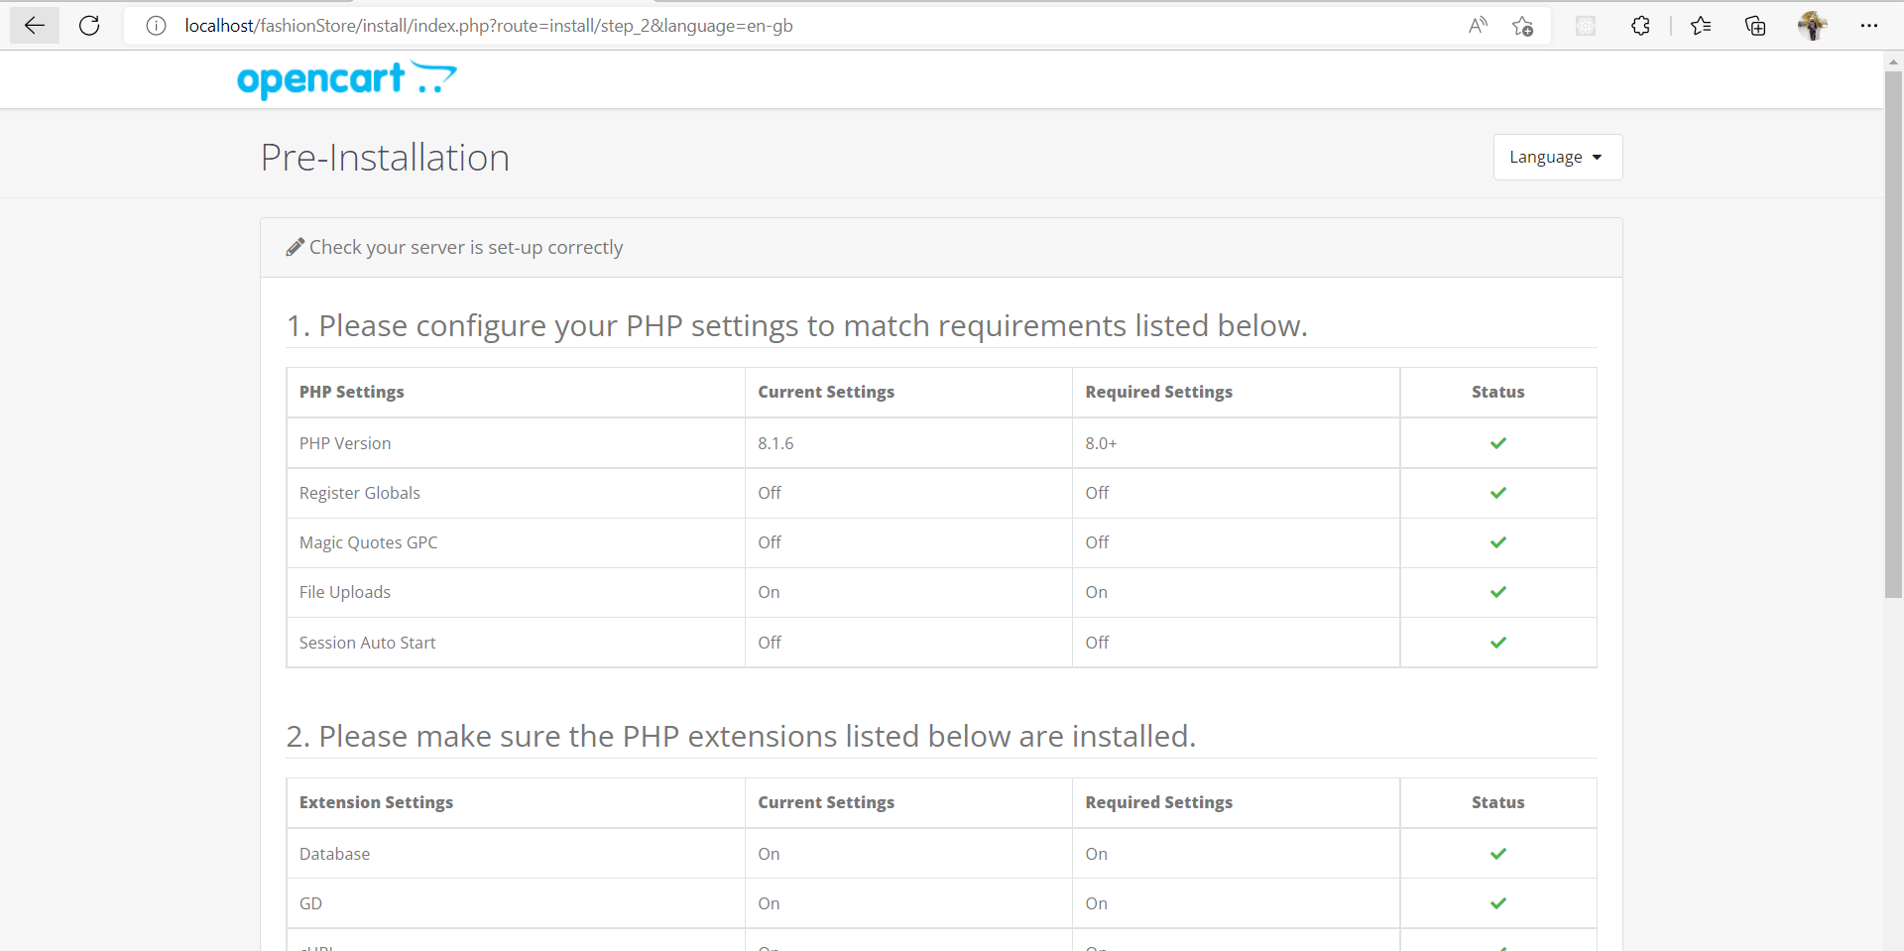

After that we need rename the config file form the **root directory** and **admin directory** which is default **config-dist.php** to **config.php,** after that we can see that the error related to the file has been resolved.

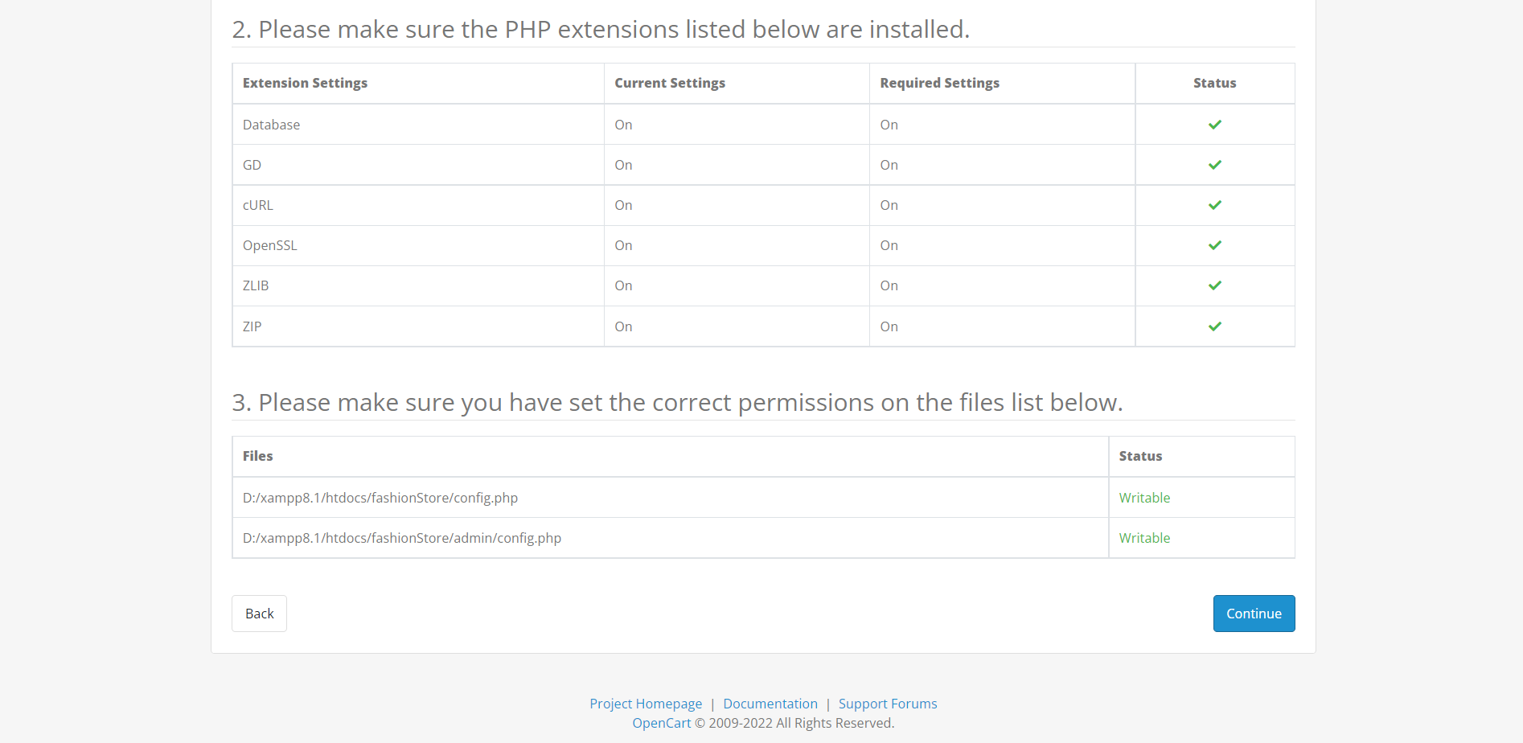

Now need to click on continue to proceed for the further process which needs related to the network configuration process like name of the **database, user name and password** of the admin for the **OpenCart** portal.

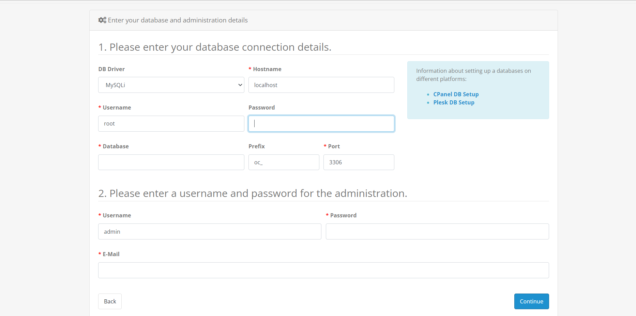

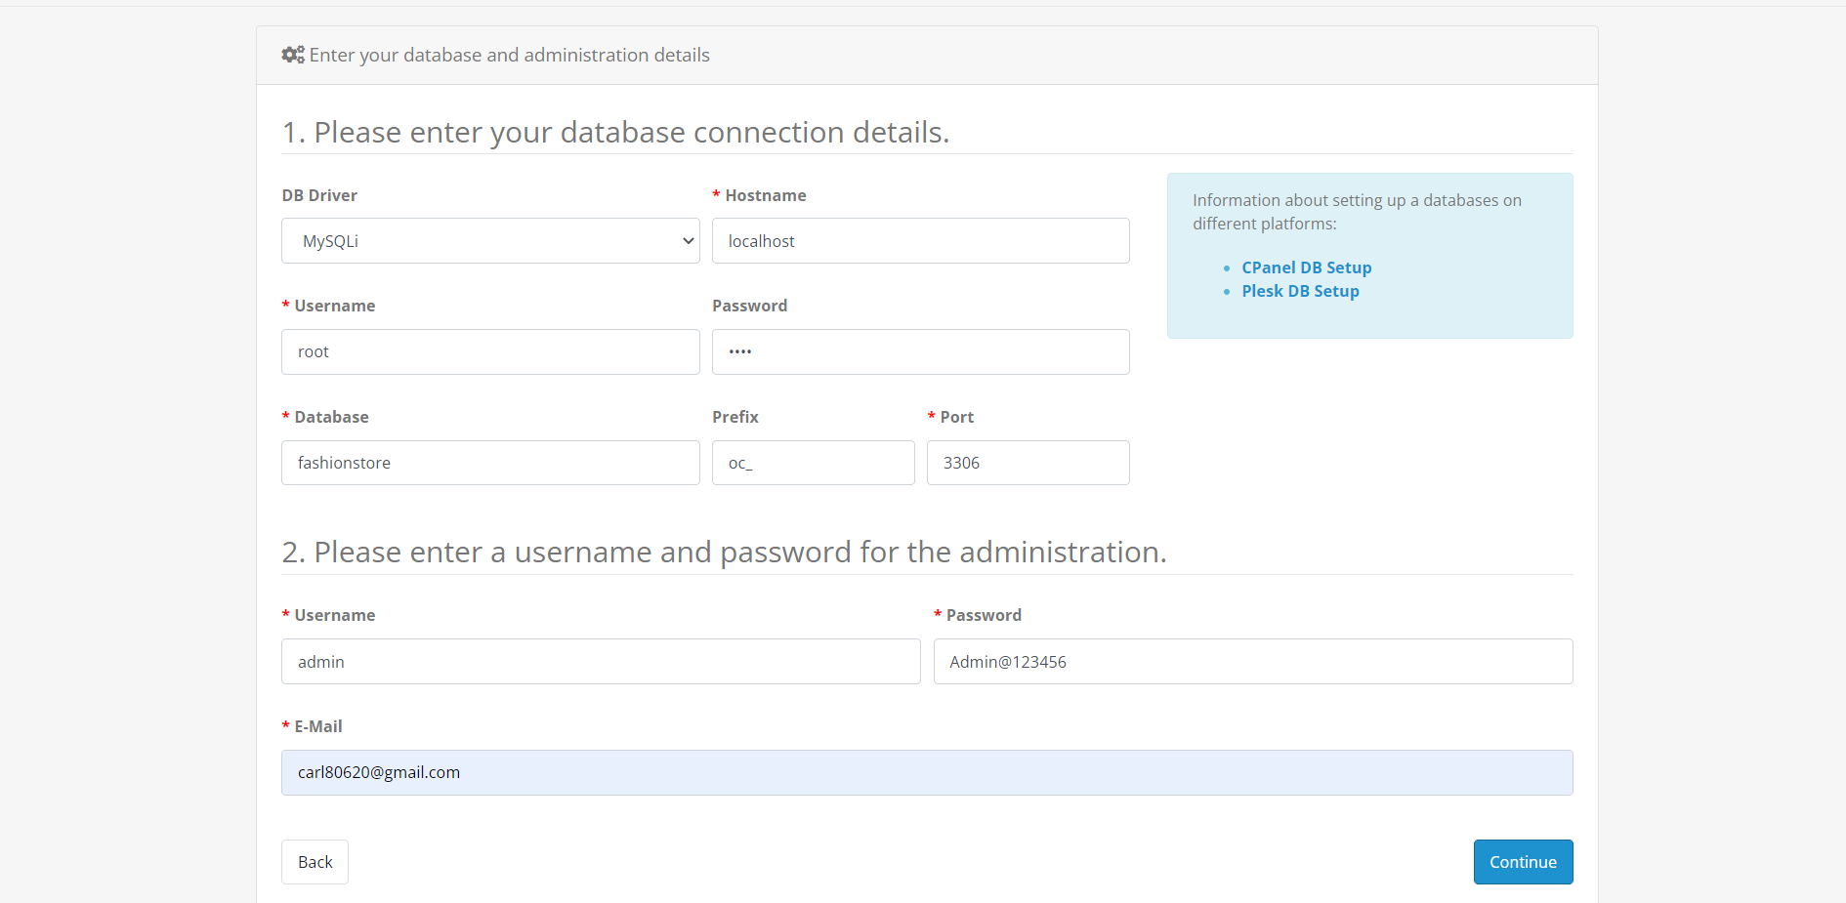

After that need to click on the continue to proceed. Here we can check that the OpenCart has been properly installed over the server.

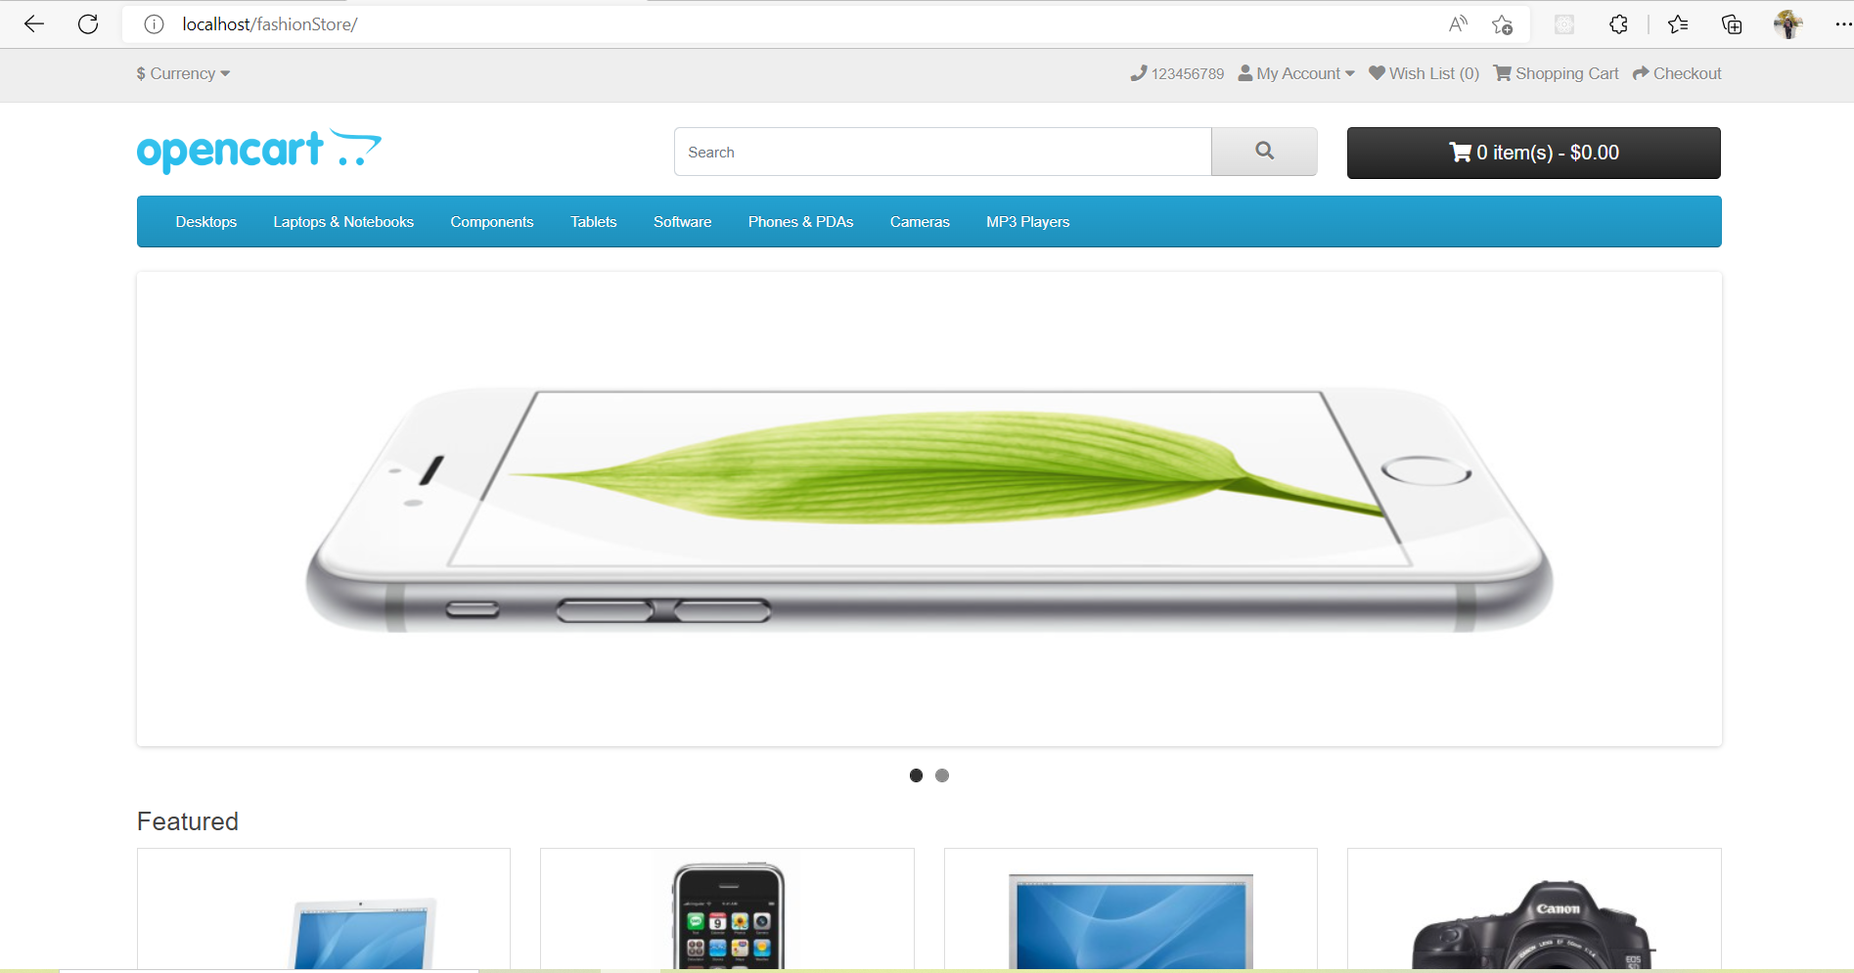

FashionStore also has two different panel like admin and local both has different view like:

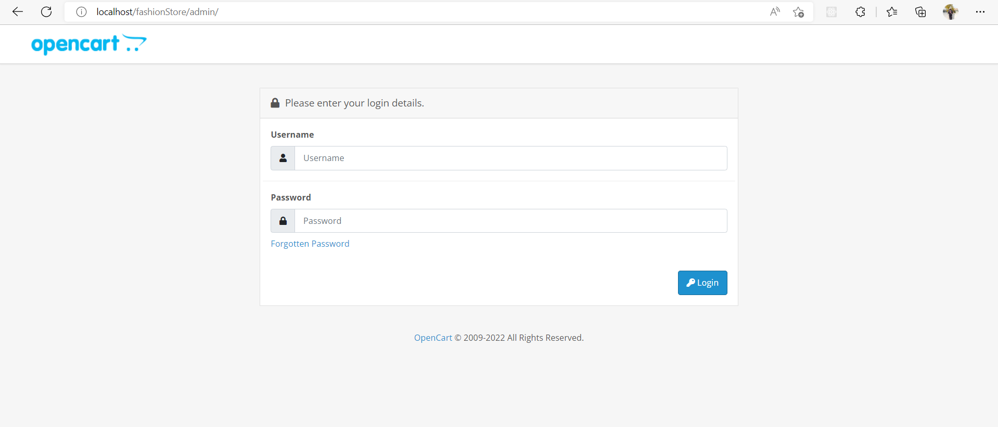

# **Things to remember after OpenCart theme installation**

When I have installed, OpenCart for the configuration when I have opened the Store at the Localhost then I got this error which is the configuration related to solve this error. Without these files we are not be able to store the details of the store like database name, user name and password etc.

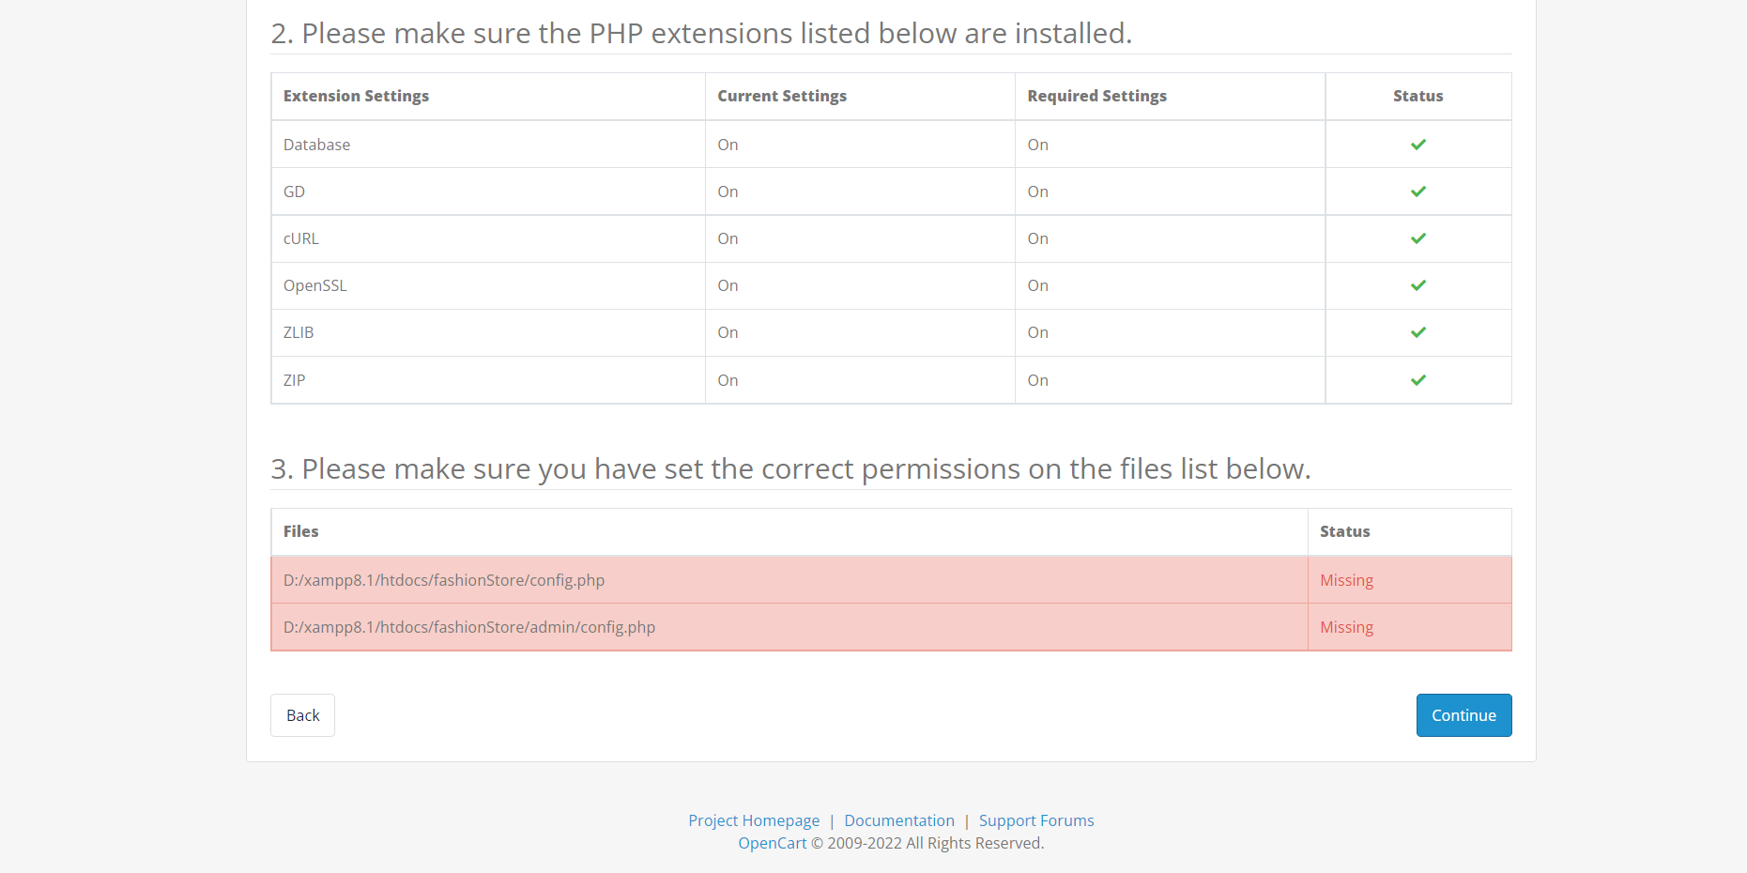

Then need to get the help of the command to fix this bug:

I need to rename the file name from the root Directory and Admin Directory from the OpenCart Store. Then the bug will be resolved, by default the name of the file would be **config-dist.php** then need to rename with the Name of **Config.php** from the both of directory.

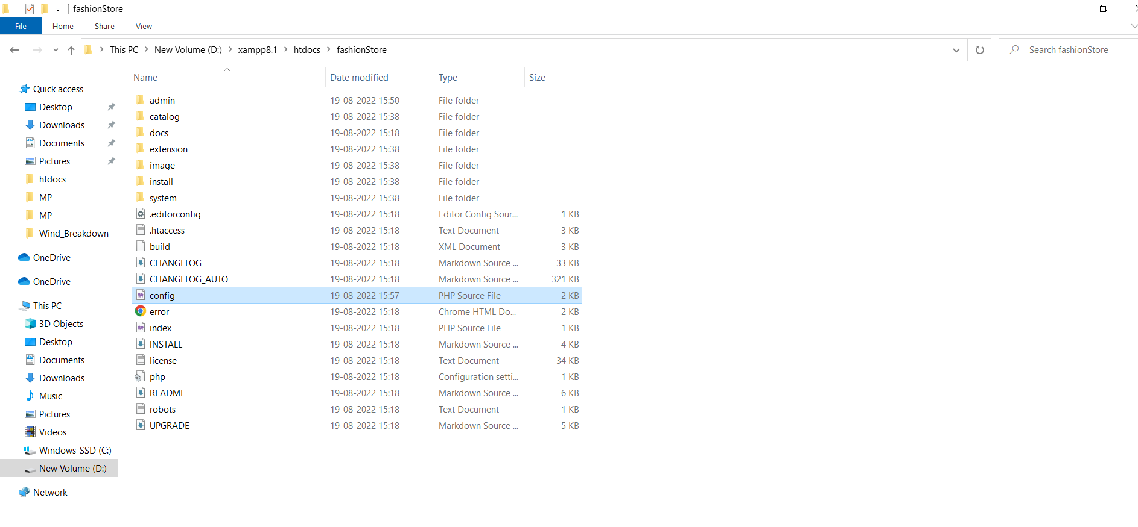

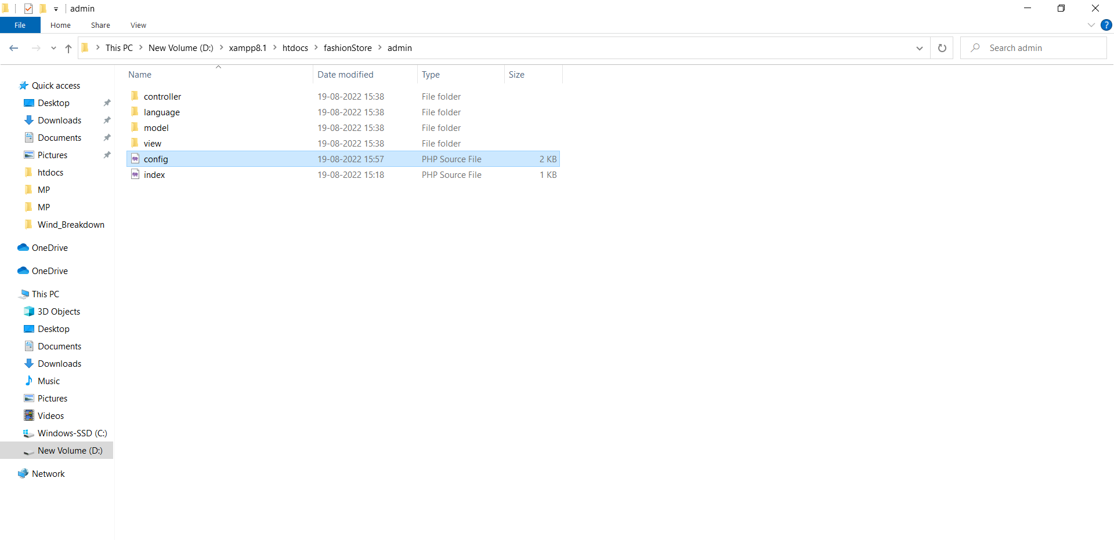

Here we can check that now the bug related to the files has been resolved.



------------------------------ END OF THE DOCUMENT --------------------------